Coding & Collaboration Platforms
Task 3 – Module 3 | CSE0001 Digital Literacy
VIT Bhopal University | Integrated M.Tech in AI | 2025–29
Name | Atharv Singh
Registration No. | 25MIM10198
Branch | Integrated M.Tech in AI
Course | CSE0001 – Digital Literacy
University | VIT Bhopal University
Task | Task 3 – Coding & Collaboration Platforms
Part A Platform | HackerRank (hackerrank.com)
Challenge Completed | Arithmetic Operations – Sum, Difference, Product
Challenge Result | PASSED – All Test Cases Accepted ✓
Part B Platform | Google Forms (forms.google.com)
Quiz Score | 4 out of 5 points (80%)

Part A – Coding Practice: HackerRank

HackerRank | hackerrank.com | @atharvsingh11201

What is HackerRank?
HackerRank is one of the world's most widely used competitive programming and technical assessment platforms. It is used by over 2,000 companies including Google, Amazon, Microsoft, and Goldman Sachs to test candidates' coding skills. For students, HackerRank provides structured practice tracks in Python, Data Structures, Algorithms, SQL, and more — all directly relevant to technical interviews and placements.

As a student of Integrated M.Tech in Artificial Intelligence, HackerRank is particularly valuable because it includes dedicated tracks for Python programming and problem-solving skills that are foundational to machine learning and AI development.

Challenge Completed: Arithmetic Operations

Challenge Name | Arithmetic Operations (Sum, Difference, Product)
Category | Algorithms / Warmup
Difficulty | Beginner
Language Used | PyPy 3 (Python)
Test Cases | Sample Test Case 0 – PASSED
Input | a = 3, b = 2
Expected Output | 5 (sum), 1 (difference), 6 (product)
My Output | 5, 1, 6 – Correct ✓
Status | Congratulations! All test cases passed

Screenshot 1 – Challenge Problem Statement (Part 1)
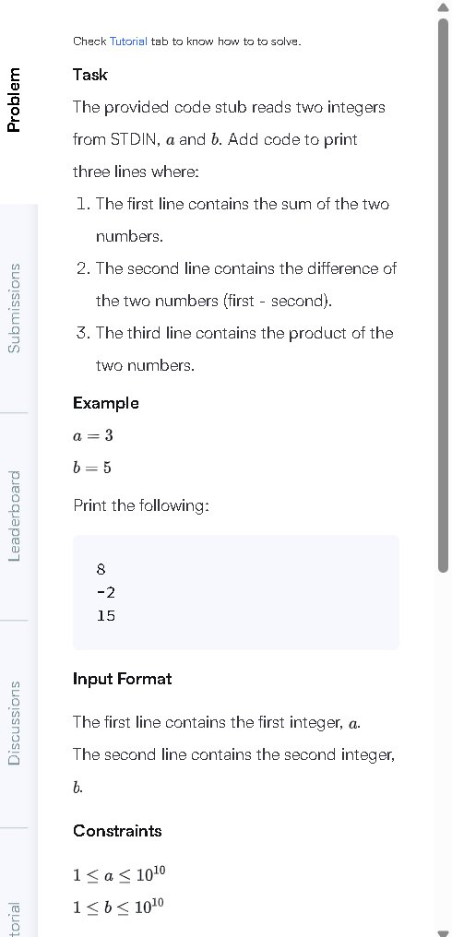
Figure 1: HackerRank – Arithmetic Operations problem statement showing task description
Screenshot 2 – Challenge Problem Statement (Part 2)
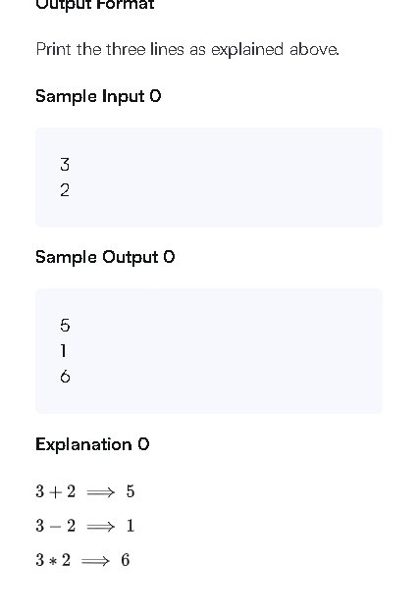
Figure 2: HackerRank – Sample input/output and explanation for the challenge
Screenshot 3 – My Python Solution Code
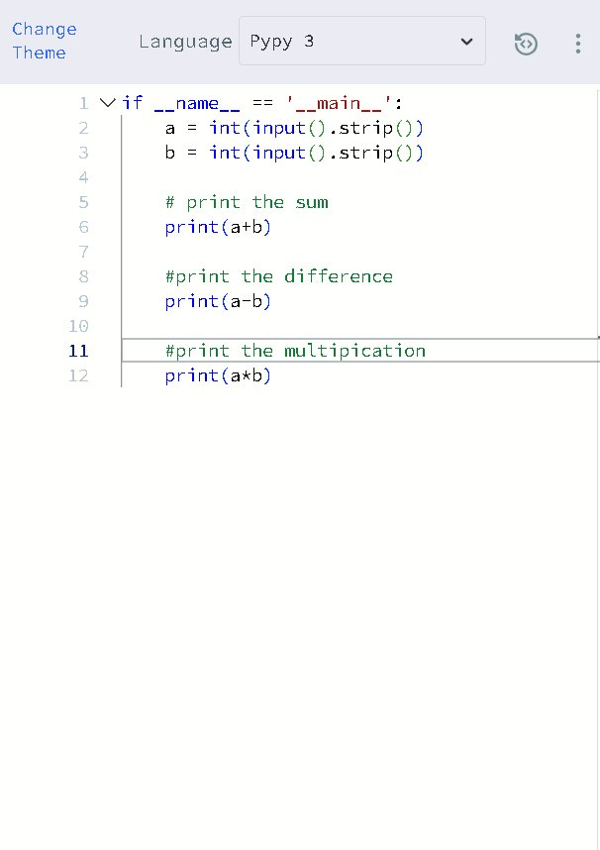
Figure 3: HackerRank – My Python solution using print(a+b), print(a-b), print(a*b)
Screenshot 4 – Test Case Result: PASSED
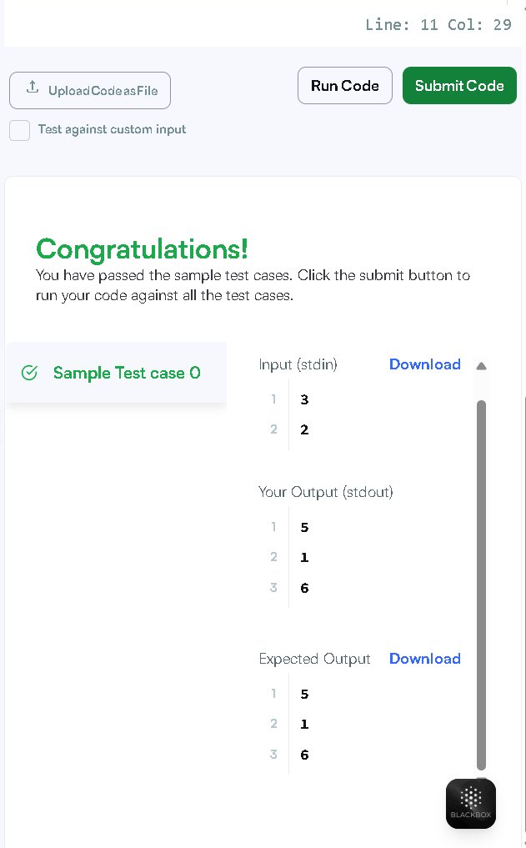
Figure 4: HackerRank – Congratulations! All test cases passed. Output: 5, 1, 6
Screenshot 5 – HackerRank Profile
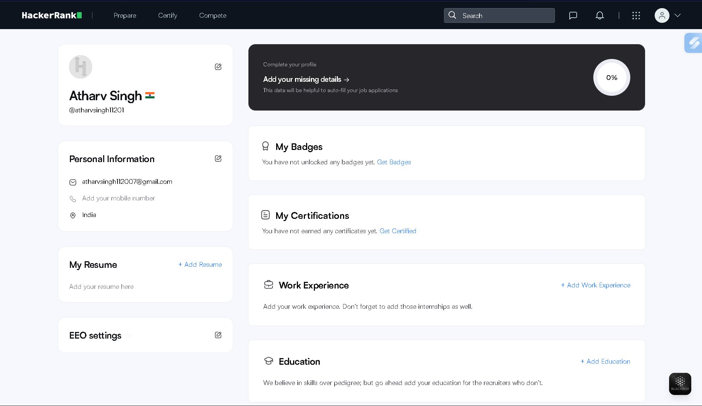
Figure 5: HackerRank Profile – Atharv Singh (@atharvsingh11201)

My Solution Explained
The challenge required reading two integers a and b from standard input, then printing three values on separate lines: the sum (a+b), the difference (a-b), and the product (a*b). I solved this using PyPy 3 (Python):

a = int(input().strip())
b = int(input().strip())
print(a+b) # Sum
print(a-b) # Difference
print(a*b) # Product

For input a=3, b=2: the output was 5 (sum), 1 (difference), and 6 (product) — matching the expected output exactly. The result showed Congratulations and confirmed all test cases passed.

Part B – Google Workspace: Digital Literacy Quiz

Google Forms | forms.google.com | Digital Literacy Awareness Quiz

What is Google Forms?
Google Forms is a free, browser-based tool that is part of Google Workspace. It allows users to create surveys, quizzes, and questionnaires that can be shared with anyone via a link. Responses are automatically collected and can be linked to Google Sheets for analysis. For students, Google Forms is used for peer surveys, quiz creation, data collection for projects, and collaborative research.

Quiz Overview
Quiz Title | Digital Literacy Awareness Quiz
Total Questions | 5 Questions
Question Types | 4 Multiple Choice + 1 Short Answer (email subject line)
Total Points | 5 Points
Quiz Mode | Enabled – score shown immediately after submission
Responses Collected | 1 response (28 Mar 2026, 15:04)
Average Score | 4/5 points (80%)
Form Link | https://docs.google.com/forms/d/1nW4lt373lywMGxNbyPWRjrtyxlFrQK9BtzucQd1CUeg/viewform

Quiz Questions

Q# | Question | Correct Answer | Result
1 | What does the term Digital Literacy mean? | C) The ability to use digital tools safely | 1/1 ✓
2 | Which of the following is a safe internet practice? | C) Enabling Two-Factor Authentication (2FA) | 0/1 ✗
3 | Which platform is best for hosting your coding projects? | B) GitHub | 1/1 ✓
4 | What should you do if you receive a suspicious UPI payment request? | B) Ignore and block the number | 1/1 ✓
5 | Correct format for a professional email subject line? | C) Request for Assignment Deadline Extension – Atharv Singh – 25MIM10198 | 1/1 ✓

Google Form Screenshots

Screenshot 6 – Form Questions 1 & 2
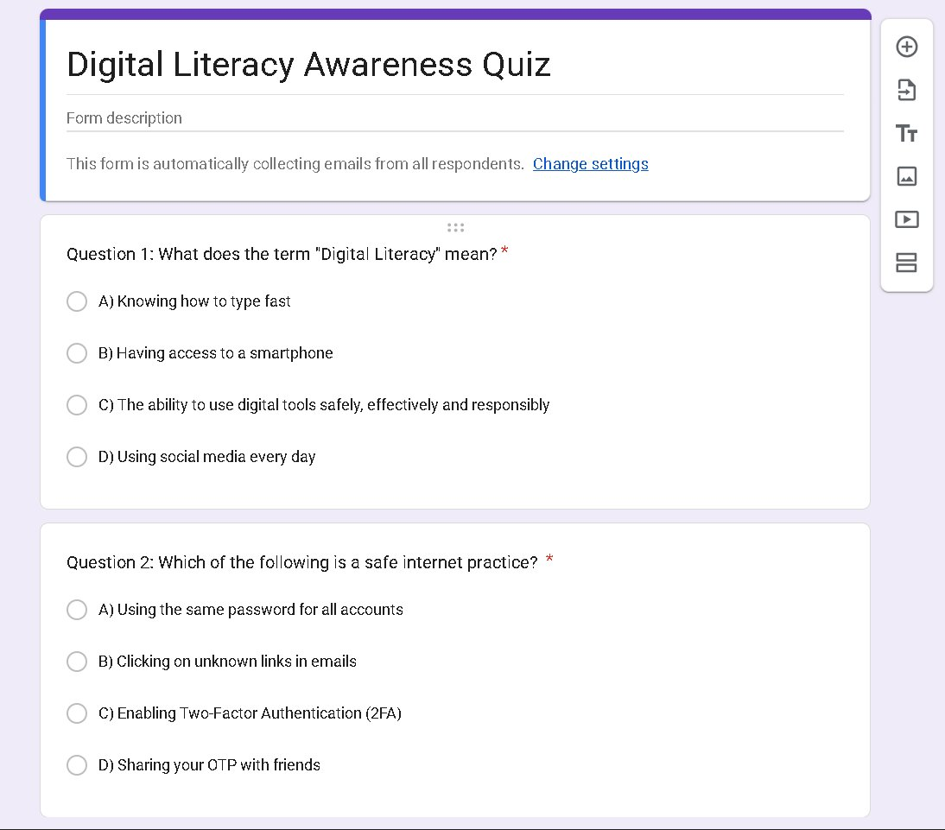
Figure 6: Google Form – Question 1 (Digital Literacy definition) and Question 2 (Safe internet practice)
Screenshot 7 – Form Questions 3 & 4
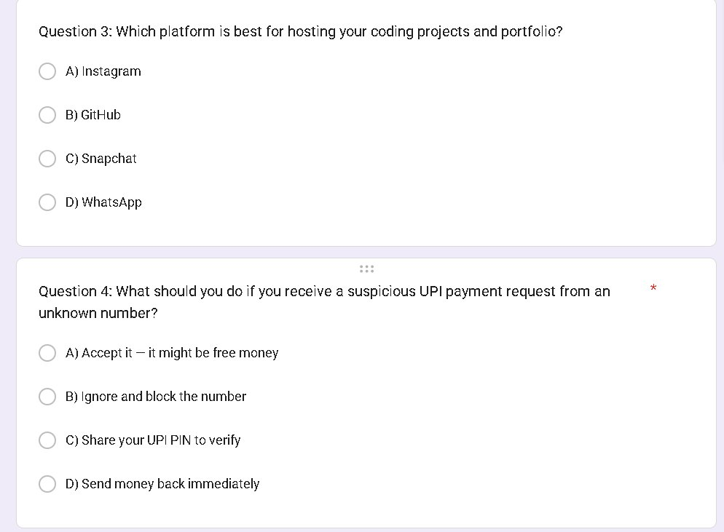
Figure 7: Google Form – Question 3 (GitHub for coding) and Question 4 (UPI fraud safety)
Screenshot 8 – Form Question 5 (Email Subject Line)
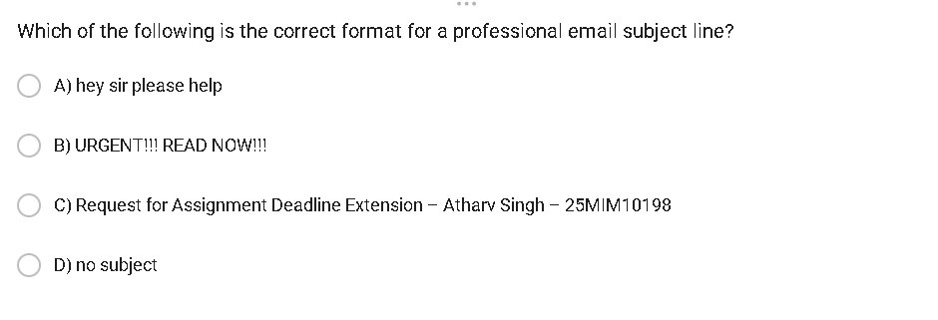
Figure 8: Google Form – Question 5 (Professional email subject line format)

Quiz Submission & Results Screenshots

Screenshot 9 – Form Submitted Successfully

Figure 9: Google Form – Response recorded confirmation page
Screenshot 10 – Score Display After Submission
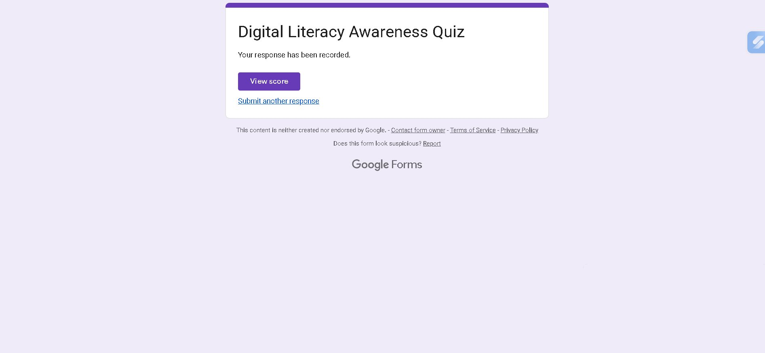
Figure 10: Quiz result – Score 4/5 shown immediately after submission
Screenshot 11 – Answer Review (Q1 Correct, Q2 Incorrect)
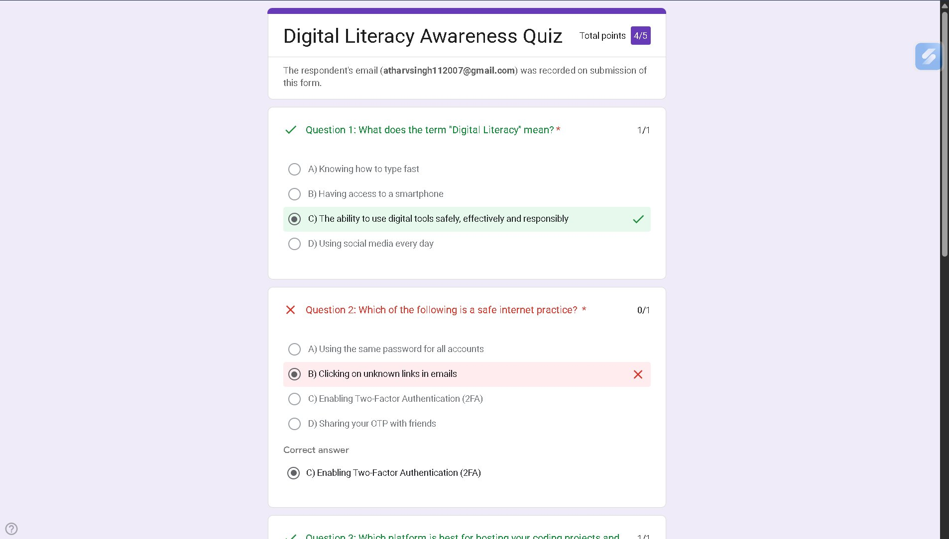
Figure 11: Answer review – Q1 correct (C selected), Q2 incorrect (B selected, C was correct)
Screenshot 12 – Answer Review (Q3, Q4, Q5 All Correct)
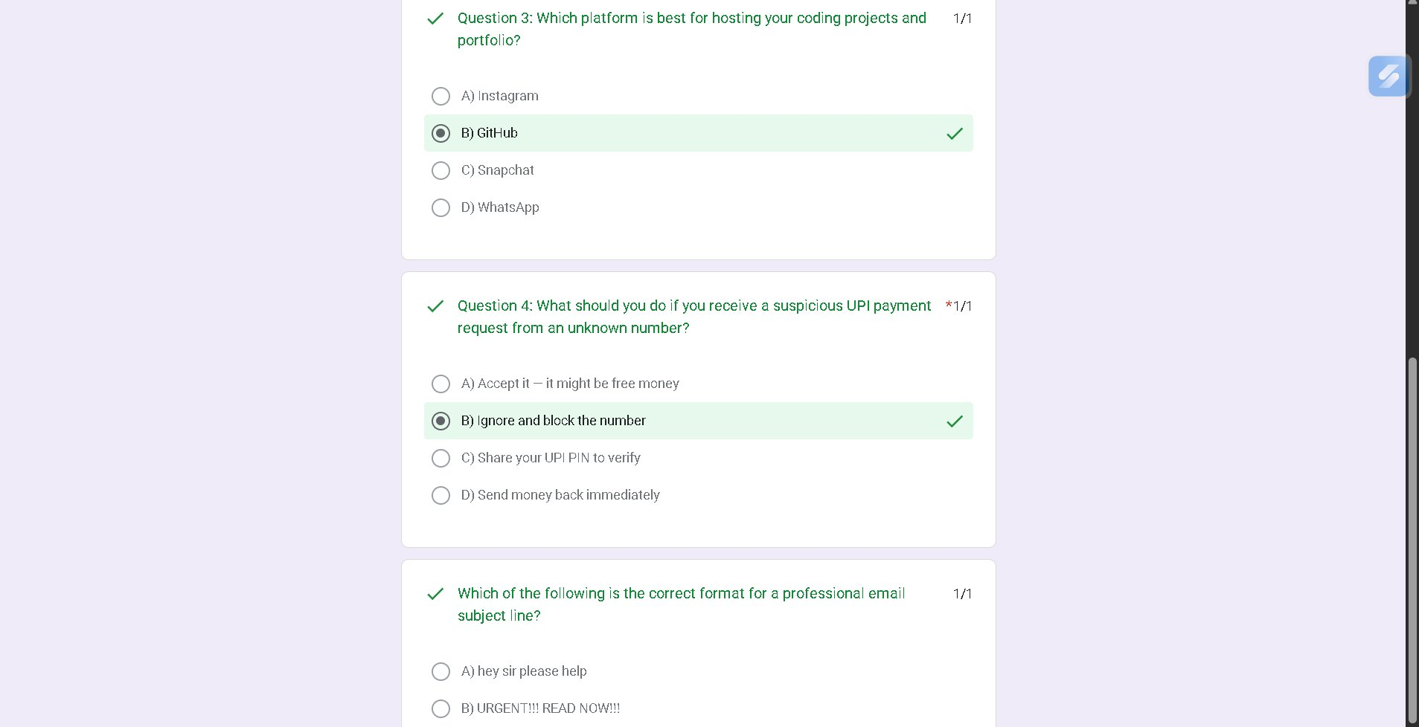
Figure 12: Answer review – Q3 GitHub correct, Q4 UPI correct, Q5 email subject correct

Google Form Responses Dashboard Screenshots

Screenshot 13 – Responses Summary & Insights
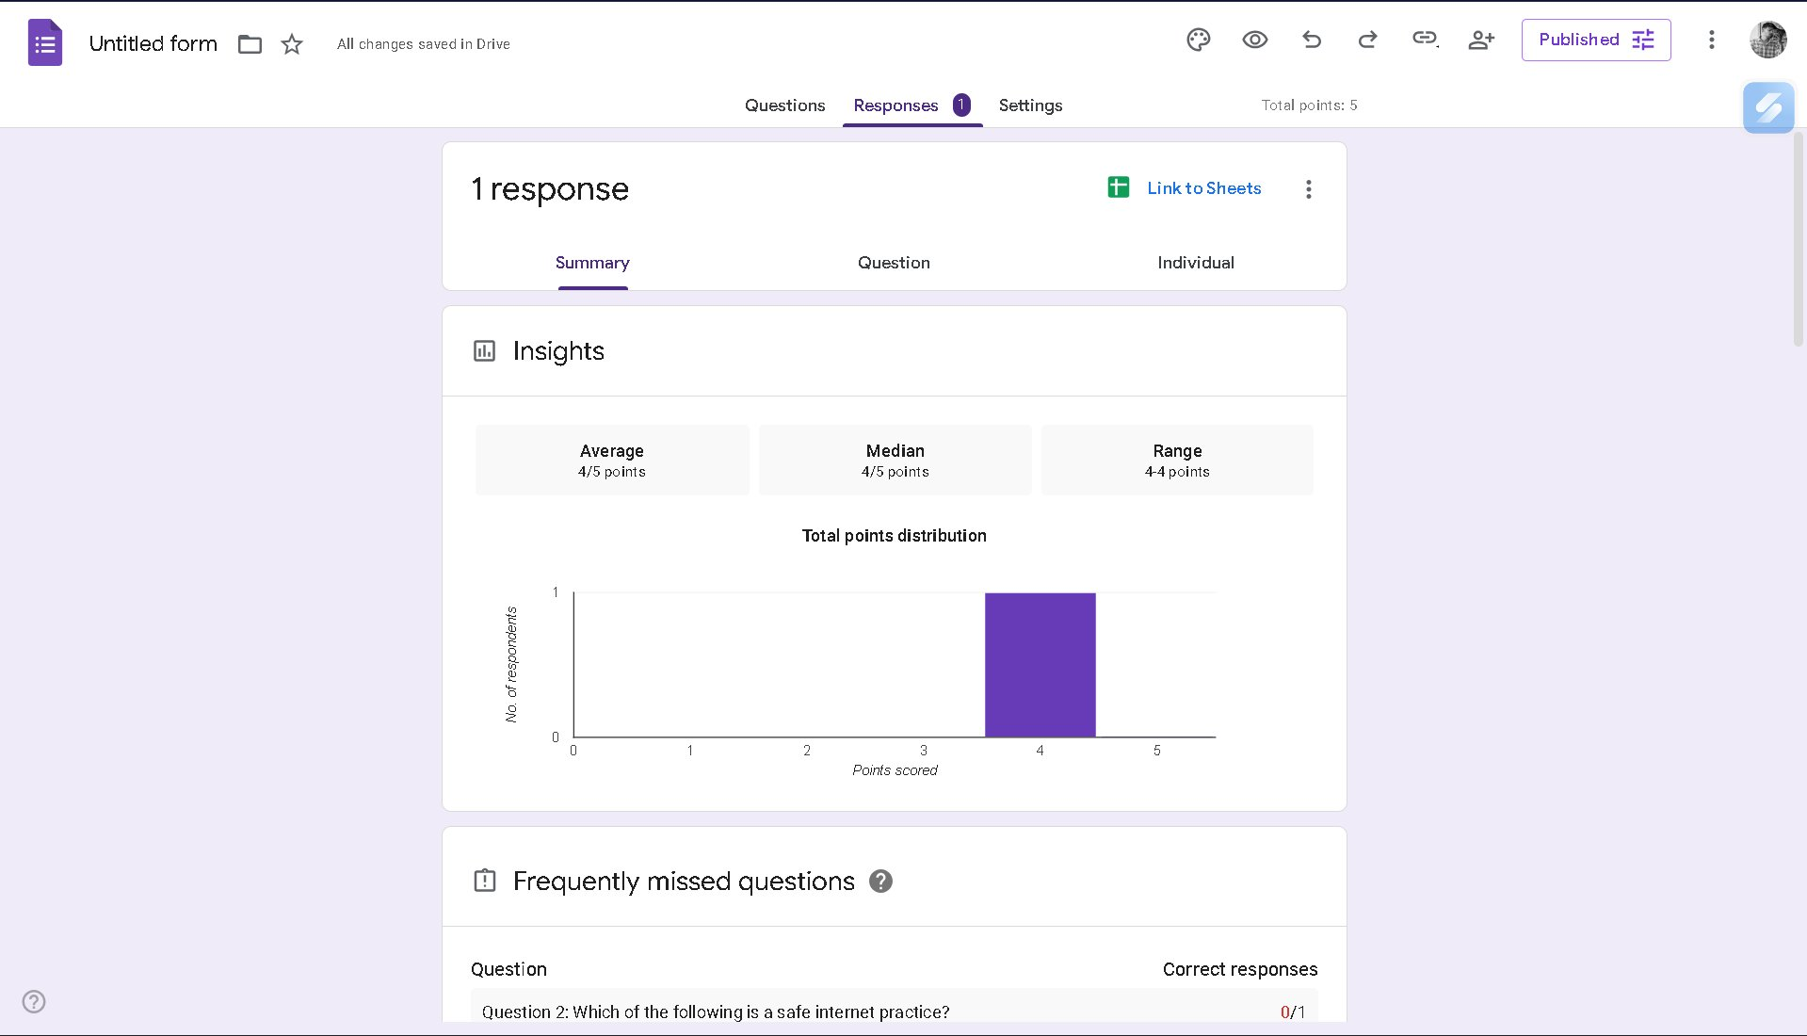
Figure 13: Google Form Responses – Summary tab showing 1 response, Average 4/5, distribution chart
Screenshot 14 – Individual Response Scores
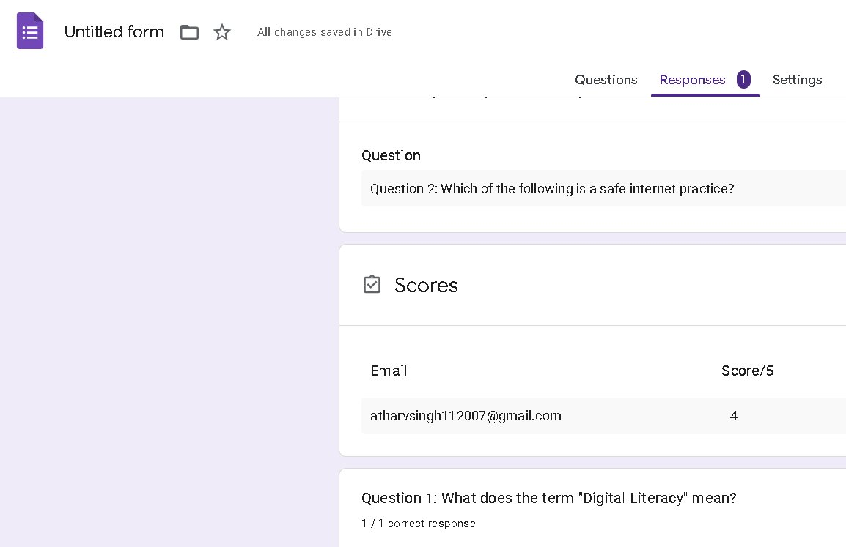
Figure 14: Responses – Individual scores showing atharvsingh112007@gmail.com scored 4/5
Screenshot 15 – Scores Tab with Release Date
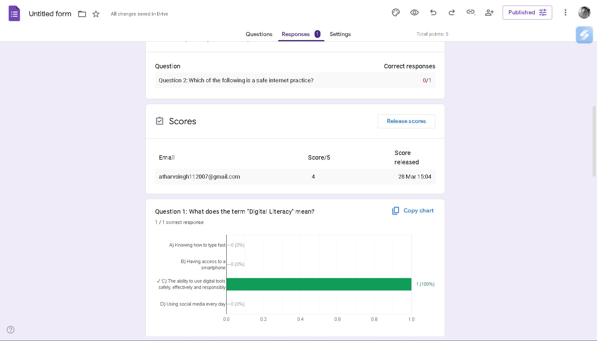
Figure 15: Scores tab – Score 4/5 released on 28 Mar 15:04, Q1 correct response chart
Screenshot 16 – Q2 & Q3 Response Charts
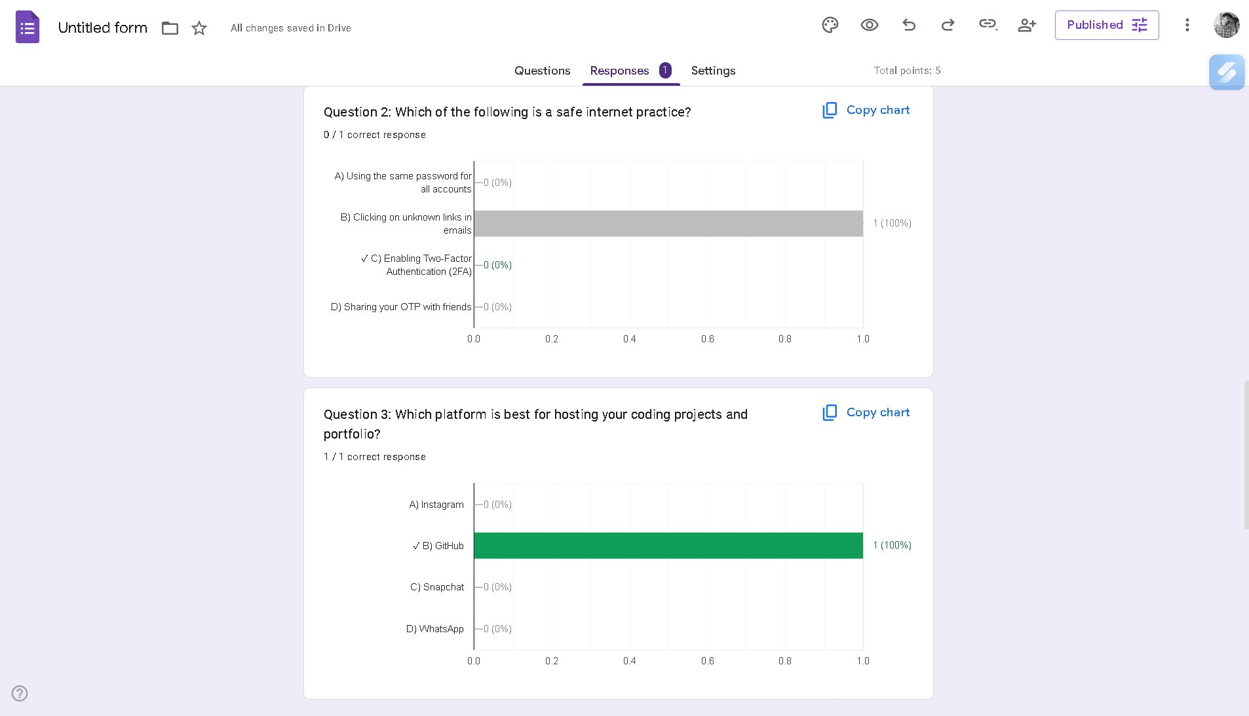
Figure 16: Response charts for Q2 (0/1 correct, B selected) and Q3 (1/1 correct, GitHub)
Screenshot 17 – Q4 & Q5 Response Charts
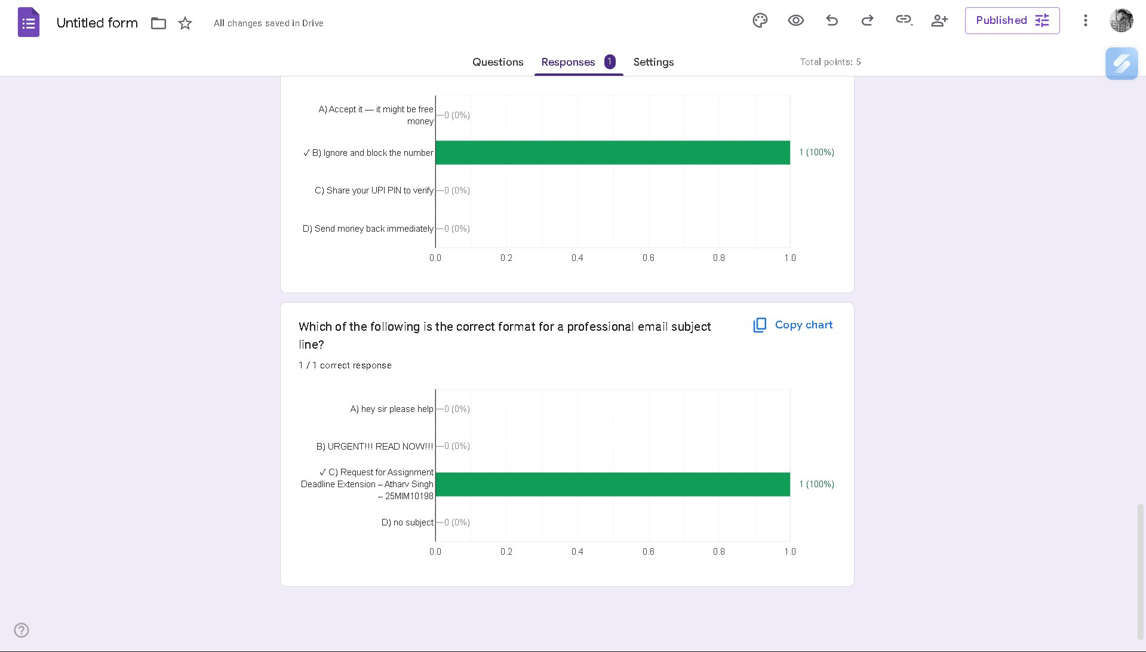
Figure 17: Response charts for Q4 (UPI fraud, 1/1) and Q5 (email subject, 1/1)

Reflection
Task 3 was divided into two practical components — coding practice on HackerRank and collaboration tool usage through Google Forms. Both parts provided valuable hands-on experience with platforms that are widely used in academic and professional settings.

For Part A, completing the Arithmetic Operations challenge on HackerRank introduced me to the platform's coding environment, test case submission system, and real-time feedback mechanism. Although the challenge was beginner-level, it demonstrated the core workflow used in all technical assessments: read the problem, write clean code, test against sample cases, and submit. For an Integrated M.Tech AI student, HackerRank is especially useful because it offers dedicated Python and Machine Learning problem sets that directly complement my coursework.

For Part B, building the Digital Literacy Awareness Quiz using Google Forms was a practical exercise in collaboration tool usage. I created a 5-question quiz with multiple-choice and short answer questions, enabled quiz mode so respondents see their scores immediately, and linked it to Google Forms' response tracking. I scored 4 out of 5 on my own quiz — getting Question 2 about safe internet practices incorrect, which was a useful reminder that even familiar topics require careful attention. The response charts automatically generated by Google Forms show how the platform can be used for real data collection and analysis — a skill directly relevant to AI research and academic projects.

Summary

Part | Platform | Activity | Result
Part A | HackerRank | Arithmetic Operations Challenge | PASSED ✓
Part B | Google Forms | Digital Literacy Awareness Quiz (5 Qs) | 4/5 Score ✓

Academic Integrity Statement

All screenshots in this document are genuine captures of my own HackerRank and Google Forms activity completed on 28 March 2026. The HackerRank solution is my own code. The Google Form was created by me and tested using my own college email. This is an individual submission for CSE0001 Digital Literacy at VIT Bhopal University.

